**THE ROLE AND EFFORTS OF THE COMMUNITY IN DEVELOPING INTRODUCING AND TEACHING INCUNG SCRIPT**

**(ORIGINAL SCRIPTURE OF THE KERINCI TRIBE)**

**M Zikril Oksa Putra¹, Yan Nurcahya², Asep Ahmad Hidayat³, Dedi Supriadi⁴**

Magister Sejarah Peradaban Islam

UIN Sunan Gunung Djati

[zikriloksa25956@gmail.com](mailto:zikriloksa25956@gmail.com)¹ [yan.itb2021@gmail.com](mailto:yan.itb2021@gmail.com)²

[dr.asephi@uinsgd.ac.id](mailto:dr.asephi@uinsgd.ac.id)³ dedi.supriadi@uinsgd.ac.id⁴

***ABSTRACT***

*The incung script is a script originating from Kerinci land which has the function of representing Kerinci language and writing for a long time. However, with the emergence of Islamic civilization and Dutch Colonial rule, quite a few Kerinci people began to be introduced to new cultures, resulting in fewer and fewer people studying, teaching and applying the existence of the incung script in people's daily lives. So this indirectly causes a decrease in the intensity of the incung script in the lives of the Kerinci community, which can make it difficult for future generations to know about its presence. Bringing back the incung script icon in the midst of society is one way to reintroduce and preserve the incung script through the medium of painting, starting from motifs on typical Kerinci batik, motifs on musical instruments, establishing incung script schools, appearing incung on every place name, street name, etc. the name of the office in the Kerinci area, and teaches school children by introducing additional subjects. So all of this can make it easier to introduce the incung script to the public.*

***Keywords: Aksara, Incung, Kerinci, Intensity***

**ABSTRAK**

Aksara *incung* adalah aksara yang berasal dari Tanah Kerinci yang memilliki fungsi untuk mewakili bahasa dan tulisan Kerinci dalam waktu lama. Tetapi dengan munculnya peradaban Islam dan penjajahan masa kolonial Belanda, tidak sedikit juga masyarakat Kerinci mulai dikenalkan dengan budaya-budaya baru, sehingga menyebabkan semakin sedikitnya orang yang mempelajari, mengajarkan dan menerapkan keberadaan aksara *incung* dalam kehidupan masyarakat sehari-hari. Sehingga secara tidak langsung menyebabkan menurunnya intensitas aksara incung dalam kehidupan masyarakat Kerinci, yang dapat mempersulit kehadirannya utuk diketahui generasi yang akan datang. Memunculkan kembali ikon aksara *incung* ditengah-tengah masyarakat adalah salah satu cara mengenalkan kembali dan melestarikan aksara *incung*. melalui media lukisan mulai dari motif pada batik khas Kerinci, motif pada alat musik, mendirikan sekolah aksara *incung*, memunculkan *incung* pada setiap nama tempat, nama jalan, nama kantor yang ada di wilayah Kerinci, dan mengajarkan kepada anak-anak sekolah dengan memunculkan mata pelajaran tambahan. Sehingga itu semua dapat mempermudah dalam upaya pengenalan aksara *incung* kepada masyarakat.

**Kata Kunci: Aksara, Incung, Kerinci, Intensitas**

**CHAPTER 1**

**INTRODUCTION**

1. **Background**

The incung script is traditional culture. Traditional culture is a culture that has its roots and has become a nation and the identity of a region (Masunah, 2003). In the past, the incung script was used to unite the Kerinci people to fight against the Dutch colonialists. This incung script almost became extinct due to the Dutch prohibiting the Kerinci people from using characters that the Dutch did not understand. So this is one of the reasons for the decline in the intensity of use of the incung script in the daily life of the Kerinci people. As it should be, the people of Kerinci are proud of the existence of the incung script as the original identity of Kerinci which is done by maintaining this culture. Moreover, if you look at the reality today, there are many young people who do not recognize their cultural identity. Many people don’t know about the incung script, which causes it to disappear and the incung script is increasingly ignored. Because basically a higher and active culture will influence a lower and passive culture through cultural contact. This increasingly shows that the cultural shift is increasingly leaning towards the west (Nahak, 2019).

In the past, incung script was created by painting or carving using hard media such as animal horns. Buffalo and goats, on bamboo, and even found on palm leaves and elephant footprints (Jauhari, Vrihaspathi, Joni B. M., Zulwachdi, 2013). In incung writing we can find characteristics that are different from existing scripts such as Rencong Renjang and Central Malay writing, this shows that the work that is hundreds of years old and made by previous people is something of high value and is very valuable in a historical context. Human civilization. To find out about the work of the Kerinci civilization in the past, you have to start by knowing where the incung script came from, without knowing the historical flow we will not be able to study correctly and precisely how the symbols of this script are depicted (Powa, 2020). Once we know the history of this script, then we can identify what efforts we can make to introduce the incung script to the people of Kerinci.

Nowadays, people have made a lot of effort to show the identity of the incung script which is expressed in the works displayed so that it becomes a culture that continues to be carried out in society. With the existence of communities such as incung schools, incung batik studios, music studios with incung themes, and art communities that include incung elements in them, this encourages people to return to learning the incung script. So that the incung script could be recognized again, which was then used as the original identity of the Kerinci tribe, which then today is juxtaposed with the incung script on signs for place names, street names and so on. Because shifts in cultural values in society are also influenced by technological advances and the influence of other cultures. Through activities carried out by arts activists who work to preserve the incung script, the influence of this shift can be overcome (Ayunda et al., 2022).

Based on the description that has been presented in the discussion above wiku is related to the process of trying to introduce the incung script to the wider community, not many people have researched it because this research is new research, therefore, the author raised it as the subject of discussion that will be researched in this research and is important for researchers to conduct an analysis of the function of society and communities in efforts to preserve the Kerinci script. One of them is the incung script which is starting to become less popular with the younger generation. This can be seen from the condition of today’s society, especially the younger generation, who are increasingly keeping up with the times, too engrossed in modern cultural trends and starting to forget their own culture. Then, how can this research become a source of literature reference on the theme of preserving the incung script? How social communities can instill culturally wise values in the community and increase people’s enthusiasm for learning about Kerinci culture.

1. **Research Methods**

This research on the preservation of the incung script uses a descriptive analytical approach by explaining existing problems and coming up with solutions to these problems. According to (Sugiyono, 2017), the meaning of Descriptive Analytics is a method that functions to describe and provide an overview of an object being studied through data that has been collected as it is without carrying out analysis to make conclusions that apply to the general public.

The author also uses document study techniques and literature study methods, where the author collects data by collecting and analyzing documents, both written documents, images, works and other media. The documents obtained are then analyzed, compared and combined (synthesis) to form a study that has systematic results. And collecting library data, reading and taking notes, as well as processing research materials that have been obtained previously (zed, 2008).

1. **Problem Formulation**

1. What is meant by incung script

2. What is the role of the community in efforts to preserve the incung script

**CHAPTER II**

**DISCUSSION**

1. **The Incung Script**

In terms of language, script is a writing system that uses symbols or a whole writing system, for example Latin script, Arabic script, Sundanese script, Javanese script, Incung script, and others. Indonesian uses Latin in alphabetical order from the letter A to the letter Z. According to the KBBI, script is a system of graphic signs that humans use to communicate. What we can conclude is that script is a system of sequences of symbols called letters which, when arranged, can give rise to a certain meaning. Aksara can also be interpreted as the alphabet in its ancient version. Meanwhile, incung in Kerinci means slanted. Because the letters in the incung script look slanted. The combination of these two words can be interpreted as a typical Kerinci alphabet letter which has a slanted shape.

The incung script is a script that comes from the Kerinci tribe, a script that is classified as a Malay script, the incung script is the only script found in central Sumatra. A script owned by one of the oldest Malay tribes. There are also those who say that the incung script is a derivative of the ancient Sumatran script or Pallawa script. Which comes from the Brahmic script used in India. The incung script was used by previous communities to write or document history, such as writing customary law, literature written on tree bark, buffalo horns, palm leaves, which is thought to be more than hundreds of years old (isskandr). The incung script was originally used as a communication medium by ancestors in the 14th century AD (1445).

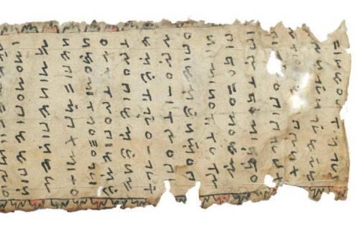

Figure 1. Daluang Manuscript in Incung script. Source: EAP Library

The image above is a form of incung script which contains the Tanjung Tanah law which contains customary rules, customary sanctions and other customary rules. Which uses daluwang ingredients.

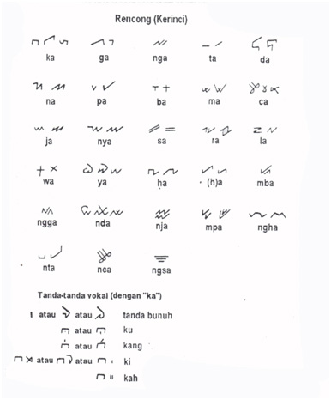

Figure 2. Kerinci Incung Script Alphabet. Source: NR Darman

Based on the picture of the incung script above, we can see that apart from the letter symbols which have consonant-vowel meanings and are marked with key signs to change the pronunciation from a to u, o and i, they not only change the letters but also change the meaning of the sound. , besides that, there are also key signs and symbols to add other sounds such as ng and to remove the sound a. The sign used to eliminate the a sound is known as the kill sign.

In the first discussion, we can draw conclusions regarding the meaning of what is called incung script. The incung script is a local script that developed in the Kerinci tribe, a script that was used by the Kerinci people in the 14th century AD, the oldest evidence found is the Tanjung Tanah law book. In the course of its history, the incung script has produced hundreds of manuscripts written in various media such as animal horns, bamboo, lontar, daluang and others. By using the native Kerinci language which is written on writing media with various contents. Generally it contains traditional news, traditional rules, tembo, coral mindu as well as several mantras and tattoos. However, it does not rule out the possibility that the incung script also contains debt letters, fines and so on.

1. **Efforts to introduce and teach the Incung script to the community**

Along with all the problems discussed above, the most common problem we encounter is how to get young people to take part in the enthusiasm for introducing the incung script. Many young people do not understand their own culture at all, because of the very strong impact of western culture, so that young people are immersed in more modern culture and ignore their own culture. Which causes foreign cultures to develop rapidly in our land and drown out our own culture. Of course, this is a tough challenge for young people, namely how young people continue to accept the new culture that comes and ignore the original culture. The following are efforts or solutions on how to introduce the incung script to people who have little or no knowledge about the incung script and instill knowledge in young people about the importance for us to maintain our own culture.

* 1. **Incung Script in Typical Kerinci Batik Motifs**

In the 1990s batik businesses appeared in the Kerinci area, but some time after that they disappeared. It was only in the 2000s that the Kerinci batik production business increased, so that many business actors emerged in the field of batik. This cannot be separated from the existence of batik in Kerinci which gives rise to various typical Kerinci motifs including the incung script. What is characteristic of Kerinci batik is the incung script, so that the old incung script which was no longer cared about was revived or reintroduced through the medium of batik. This increases the popularity of the incung script so that it can be introduced easily by young people.

The Sungai Penuh City Government is also focusing on developing this batik, in an effort to develop tourism, culture, maintaining the incung script and the creative economy, the government is starting to bring back the typical batik of Sungai Banyak, in a circular submitted by the Sungaifull City Government, that it is mandatory for all government agencies in the area. Within the scope of Sungai Banyak City to apply or use batik uniforms with incung script on certain days. Apart from improving the creative economy, it is also a way to introduce literacy to the wider community.

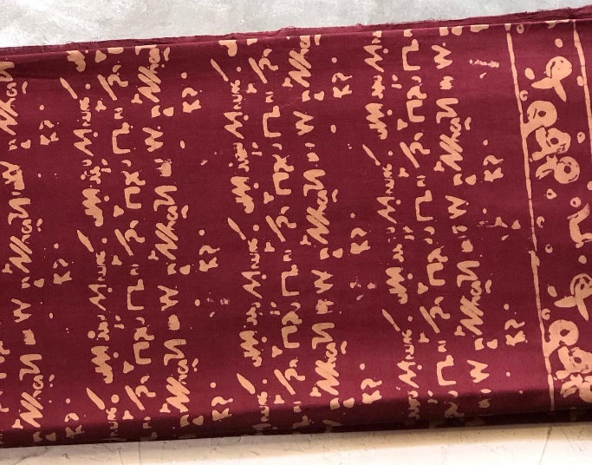

Figure 3. Incung script motif in Kerinci Batik

With batik motifs that feature the incung script, it can increase creativity for young people to come up with various new innovations, from making uniforms with the incung script motif, from incung shirts, bags produced by incung batik, jackets with the incung script motif. So that indirectly, daily activities carried out by wearing clothes that display the identity of the incung script can increase people’s interest and love for the culture that already exists in us.

* 1. **Incung Motif on Traditional Musical Instruments of the Kerinci Tribe**

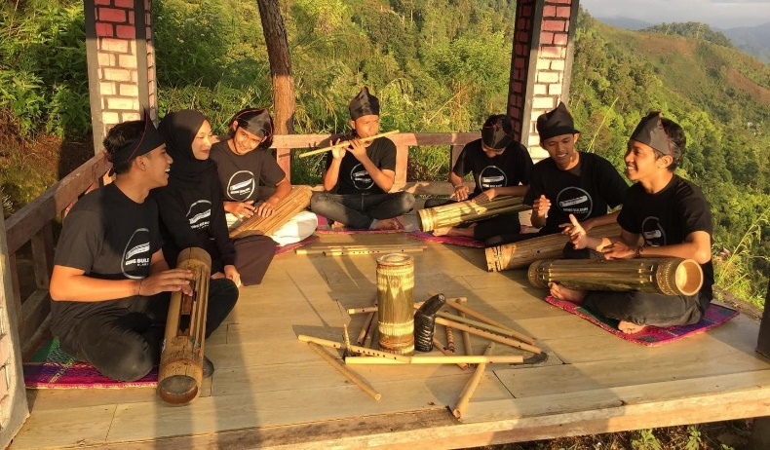

Figure 4. Incung script motif on traditional musical instruments (Gong Buleuh)

In an effort to preserve the incung script, creativity will emerge in society. Apart from the incung script being taught to the public directly, the incung script is also introduced through image media, such as motifs on batik, and bringing out the incung identity in the images displayed on typical Kerinci musical instruments. The presence of batik motifs on traditional musical instruments can increase the scope for efforts to introduce the incung script in external life, so that many young people who join the studio become pioneers in introducing Kerinci culture.

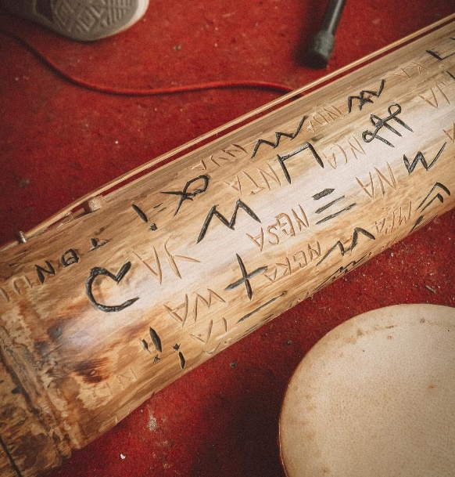

Figure 5. Incung script on traditional musical instruments (Gong Buleuh)

* 1. **Incung School**

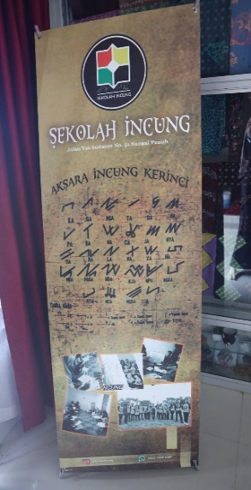

Figure 6. Incung School

(Ayunda et al., 2022) The incung school was the idea of the Kerinci humanist Iskandar Zakaria (1942-2020). Incung schools have the aim of preserving culture and eradicating illiteracy. Incung schools involve volunteers. Volunteers who come from all over Kerinci to become teachers in classes held at the Incung school secretariat which was founded voluntarily without any assistance from the government. It's not like schools in general, it doesn’t have complete buildings and facilities. Incung school is just an ordinary community founded with the aim of preserving culture. With all the limitations they have and without any support from the City Government, this does not break the enthusiasm of the founders, members and volunteers of the Incung school in encouraging the younger generation to be active in preserving culture.

Incung schools have an educational function as a forum for activities to help and support success and mastery in the fields of knowledge and skills. The incung school is a place for people to learn the original Kerinci script (incung script) with the aim of always maintaining the existence of Kerinci culture, and introducing Kerinci culture to the wider community. Incung school also aims to instill in young khawla the value of love for the importance of preserving our culture. Educate with enthusiasm to learn and apply Kerinci culture in everyday life.

The incung script for the Kerinci tribe is not just a traditional culture left behind by their ancestors. However, incung script is also a medium for education and teaching about literacy such as reading and writing culture, especially to the younger generation. In the current era of technological development, the younger generation is very easily influenced by cultures that come from outside. The incung school is a social structure that aims to preserve the culture believed in by the Kerinci people. One of them is the incung script. The incung school as a social structure forms a new system that is able to invite the people of Kerinci to return to studying a culture that has begun to become extinct. With the existence of incung schools that accommodate young people to learn, efforts can be made to solve the problem called illiteracy.

**CONCLUSION**

In the discussion above, it can be concluded that behind all the existing problems relating to the lack of knowledge of the incung script by the younger generation, the lack of knowledge and the low level of love of young people for the incung script, there are no attitudes or efforts to preserve regional culture by the younger generation. So all of this is one of the causes of the general public’s lack of familiarity with the incung script. So that various kinds of methods have emerged which have been launched by creative people to eradicate existing problems. By bringing up new methods of introduction, one of which is by adding the incung script to community activities so that people are aware of the existence of the incung script culture. Such as appearing in batik motifs, paintings and carvings on musical instruments and establishing incung schools. So all of this can expand the scope for people to know what is said in incung script. So it also becomes a trigger for people to want to learn the incung script and preserve it.

**BIBLIOGRAPHY**

Ayunda, T. S., Fitriani, E., & Amri, E. (2022). Fungsi Sekolah Incung dalam Pelestarian Aksara Kerinci. *Culture & Society: Journal Of Anthropological Research*, *4*(2), 113–123. https://doi.org/10.24036/csjar.v4i2.111

Bahrudin, Babul, Masrukhi, & Hamdan T. A. (2017). Pergeseran Budaya Lokal Remaja Suku Tengger Di Desa Argosari Kecamatan Senduro Kabupaten Lumajang. Journal of Educational Social Studies 6(1):20–28

Jauhari, Vrihaspathi, Joni B. M., Zulwachdi, & Y. (2013). Mengenal Aksara Incung Suku Kerinci Daerah Jambi. *Lembaga Bina Potensia*.

Masunah, j. (2003). *Angklung Di Jawa Barat Sebuah Perbandingan. Pusat Penelitian Dan Pengembangan Pendidikan Seni Tradisional.*

Nahak, H. M. (2019). Upaya Melestarikan Budaya Indonesia Di Era Globalisasi. *Jurnal Sosiologi Nusantara*, *5*, 65–76.

Powa, J. E. (2020). Implemensi Aksara Incung Di Sungai Penuh. *Jurnal Ilmiah Dikdaya*, *10*, 111.

Sugiyono. (2017). Metode Penelitian Kuantitatif, Kualitatif Dan R&D. *Alfabeta*.

Suryani, I. & Asriyani S. (2017). Strategi Komunitas Betawi Dalam Mempromosikan Tradisi Palang Pintu (Studi Kasus Pada Event Festival Palang Pintu XI). Jurnal Komunikasi 8(2):5.

Wulandari, Nopiyanti, Rudy G., & Desvian B. (2019). Keberadaan Komunitas Masyarakat Adat Karuhun Urang (AKUR) Dalam Pelestarian Budaya Sunda Wiwitan: Studi Kasus Di Cigugur, Kuningan. Chronologia 1(2):84–104.

Yusuf, M. (2014). Metode Penelitian Kuantitatif, Kualitatif Dan Penelitian Gabungan. Jakarta: Prenamedia group

Suryani, Lilis; Nurizzati (2019). “Alih Aksara dan Alih Bahasa Teks Tasawuf dan Ta’bir Gempa”. Jurnal Bahasa dan Sastra (dalam bahasa Inggris). 6 (3): 4. Doi:10.24036/81037290

Febriana, Supriadi Azis; Jamjam, Ajang; Supianudin, Asep (2018). “Naskah Hikayat Abdul Samad: Suntingan Teks dan Kajian Struktur”. Jurnal UIN Sunan Gunung Djati. Hlm. 268.

Dewi, Trie Utari. 2018. “Pembelajaran Filologi Sebagai Salah Satu Upaya dalam Mengungkap dan Membangun Karakter Suatu Bangsa”. Jurnal Pendidikan Sejarah dan Riset Sosial Humaniora. Hlm. 54.

Fatoni, Ahmad Sirfi. 2021. “Pernik-Pernik Metode dan Pendekatan dalam Penelitian Filologi”. Jurnal Mahasantri. Hlm. 351.

Nurcahya, Yan. 2021. Revitalization Skywaklk Bandung 2021 Reviving The Urban Area “Urban Space” in Bandung. https://doi.org/10.17509/jare.v3i2.35802