**APPENDICES**

**Appendix 1. “You and Insecurities” Novel**

The following is the form of “You and Insecurities” novel from the front and back.

 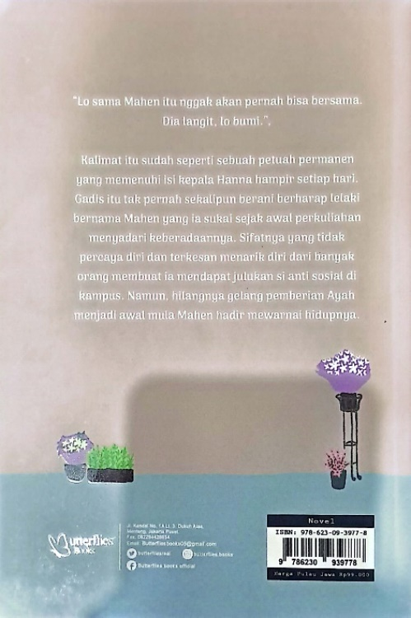

**Appendix 2. The Pages of “You and Insecurities” Novel**

The following are some pages in “You and Insecurities” novel that contain code switching.

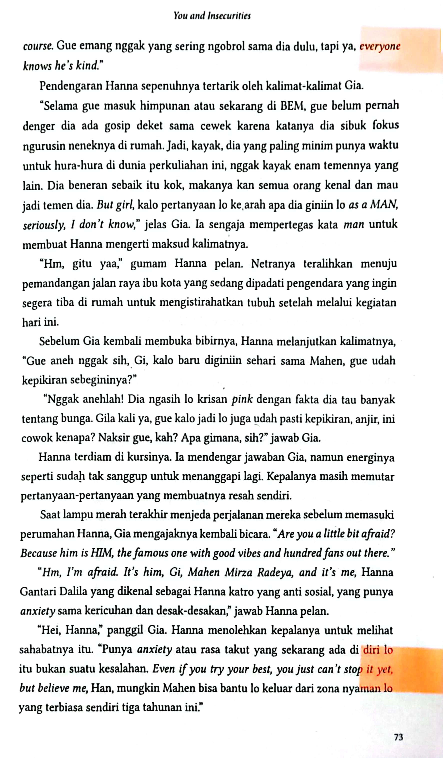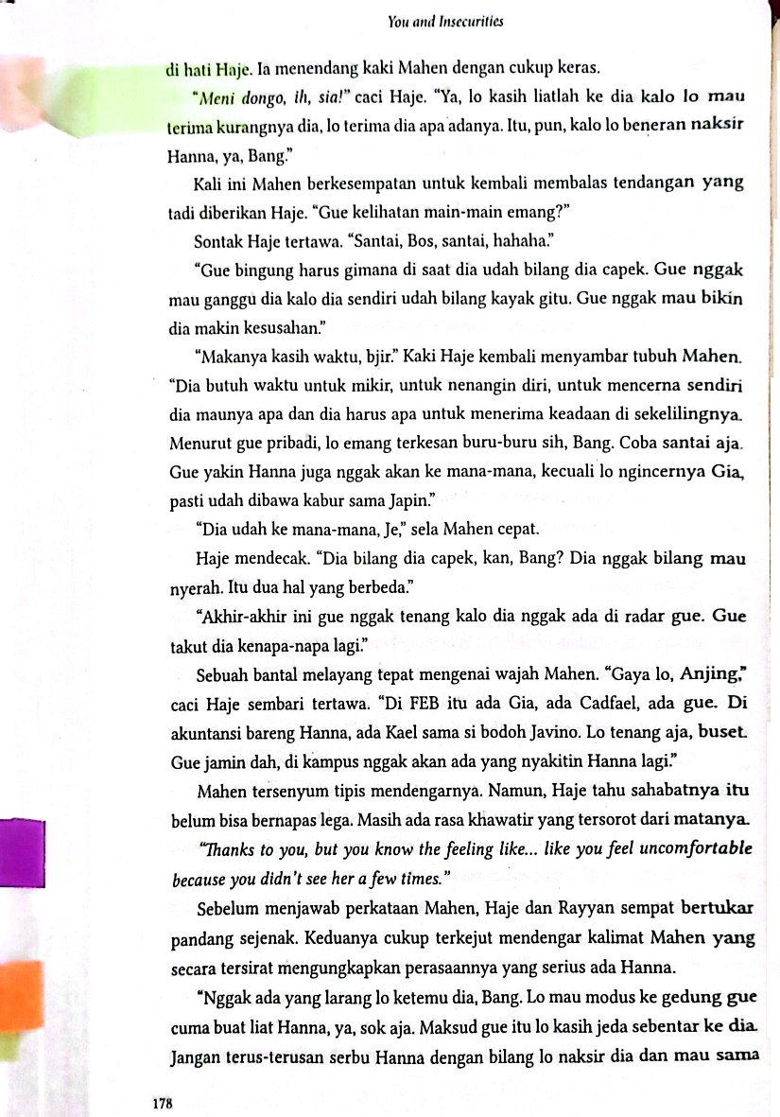

**Appendix 3. Analysis of Code Switching in “You and Insecurities” Novel**

The following is table for analyzing the types and the functions of code switching found in “You and Insecurities” novel.

|  |  |  |  |  |
| --- | --- | --- | --- | --- |
| No. | Utterances | Page | Types of Code Switching | Functions of Code Switching |
| 1. | *“Tapi, si Rayyan ini emang pembawaannya tegas nggak, sih?* **I mean***, dia dipilih jadi wakil Kak Satya pasti supaya bisa mengimbangi cara kerja Kak Satya yang penyabar dan punya toleransi yang besar.”* | 14 | Tag Switching | Talking about Particular Topic |
| 2. | *“Nggak mau.* **BIG NO***. Gue mager.”* | 15 | Inter-sentential Code Switching | Repetition Used for Clarification |
| 3. | *“***Please, do it with me***. Dua orang di tim gue nggak bisa hadir besok, jadi gue butuh orang tambahan.”* | 15 | Inter-sentential Code Switching | Talking about Particular Topic |
| 4. | *“Ih, Han, pokoknya Cuma lo yang bisa bantuin gue besok.* **So, please, please, please?***”* | 15 | Tag Switching | Talking about Particular Topic |
| 5. | *“***Let me guess***. Kak Satya yang nyuruh Kak Rahmi bantuin tim lo?”* | 18 | Inter-sentential Code Switching | Talking about Particular Topic |
| 6. | *“Iya.* **By the way***, gue besok nunggu di ruangan mana?”* | 20 | Tag Switching | Talking about Particular Topic |
| 7. | *“***Bills on me**. *Gue balik duluan, nyokap di rumah.”* | 20 | Inter-sentential Code Switching | Talking about Particular Topic |
| 8. | *“Eh,* **by the way***, koor peralatan siapa, Ray? Lupa gue.”* | 21 | Tag Switching | Talking about Particular Topic |
| 9. | *“Iya, nggak apa-apa. Santai aja, oke?* **Keep calm**.*”* | 24 | Inter-sentential Code Switching | Repetition Used for Clarification |
| 10. | *“***Let me help you***. Sini, duduk di kursi.”* | 26 | Inter-sentential Code Switching | Being Emphatic about Something |
| 11. | *“Sini, duduk di kursi.* **Be careful***, pelan-pelan aja jalannya.”* | 26 | Intra-sentential Code Switching | Repetition Used for Clarification |
| 12. | *“Gue ke panggung dulu.* **Take care of your friend, Gi***. Lukanya dibersihin.”* | 26 | Inter-sentential Code Switching | Being Emphatic about Something |
| 13. | *“***It’s okay, Han. I’m here***. Kita pura-pura budek saja. Santai, kan lo sama gue.”* | 28 | Inter-sentential Code Switching | Being Emphatic about Something |
| 14. | *“Iya.* ***Thank you for the new unexpected experience****, ya.”* | 29 | Inter-sentential Code Switching | Talking about Particular Topic |
| 15. | *“Hahaha. Jadi, gimana rasanya jatoh di depan Mahen,* **your crush for two years?***”* | 29 | Intra-sentential Code Switching | Expressing Group Identity |
| 16. | *“***I know where I am, and I’ll enjoy it until the end***. Gue balik ya, Gi.* **Thank****you and see you tomorrow!***”* | 30 | Inter-sentential Code Switching | Talking about Particular Topic |
| 17. | *“***I’m just asking, Bro***. Ya, udah deh, gue balik, ya.* **Thanks** *infonya.”* | 32 | Inter-sentential Code Switching | Taking about Particular Topic |
| 18. | *“Gue makan di rumah aja sama Oma.* **Thanks ya, Bro***.”* | 32 | Inter-sentential Code Switching | Taking about Particular Topic |
| 19. | *“Ah, ya udah deh. Entar gue suruh dia* chat *lo aja.* **Anyway, thanks** *ya.”* | 49 | Inter-sentential Code Switching | Taking about Particular Topic |
| 20. | *“***So, you’re here, Hanna?** *Menghindar dari banyak orang?”* | 57 | Inter-sentential Code Switching | Talking about Particular Topic |
| 21. | *“***I’m sorry***. Serius, gue minta maaf banget. Gue nggak akan ngelakuin hal itu lagi.”* | 58 | Inter-sentential Code Switching | Repetition Used for Clarification |
| 22. | *“Kembaliannya kapan-kapan aja gue ambil. Gue mau ke kampus lagi, ada perlu.* **It was nice to talk with you, Hanna.***”* | 60 | Inter-sentential Code Switching | Taking about Particular Topic |
| 23. | *“Dia di belakang Gia, Ray.* **Gia hid her last night.***”* | 62 | Inter-sentential Code Switching | Repetition Used for Clarification |
| 24. | *“****Surprisingly, he knows. I asked him, and he answered me arrogantly****. Dia kayak nanya ‘lo bisa cek di Google kalo nggak tau arti bunga krisan* pink*.”* | 67 | Inter-sentential Code Switching | Taking about Particular Topic |
| 25. | *“***By the way***, lo udah ngecek belum si Mahen* posting story Instagram *lagi di* florist *lo?”* | 67 | Tag Switching | Talking about Particular Topic |
| 26. | *“***By the way***, jangan mikir jelek dulu ya, haha.”* | 70 | Tag Switching | Talking about Particular Topic |
| 27. | *“Jadi ya,* **I guess***, kita bisa jadi temen ke depannya?”* | 70 | Tag Switching | Talking about Particular Topic |
| 28. | *“Ck,* **trust issues***, ya, lo?”* | 72 | Intra-sentential Code Switching | Expressing group identity |
| 29. | *“***Hm, honestly, he’s so kind, I mean he gentle as man, of course***. Gue emang nggak yang sering ngobrol sama dia dulu, tapi ya,* everyone knows he’s kind*.”* | 72 | Inter-sentential Code Switching | Talking about Particular Topic |
| 30. | *“Gue emang nggak yang sering ngobrol sama dia dulu, tapi ya,* **everyone knows he’s kind***.”* | 72 | Intra-sentential Code Switching | Talking about Particular Topic |
| 31. | *“Dia beneran sebaik itu kok, makanya kan semua orang kenal dan mau jadi temen dia.* **But girl***, kalo pertanyaan lo ke arah apa dia giniin lo* **as a MAN, seriously, I don’t know***.”* | 73 | Intra-sentential Code Switching | Talking about Particular Topic |
| 32. | *“***Hm, I’m afraid. It’s him, Gi, Mahen Mirza Radeya, and it’s me***, Hanna Gantari Dalila yang dikenal sebagai Hanna katro yang anti sosial, yang punya* anxiety *sama kericuhan dan desak-desakan.”* | 73 | Intra-sentential Code Switching | Talking about Particular Topic |
| 33. | *“Punya* **anxiety** *atau rasa takut yang sekarang ada di diri lo itu bukan suatu kesalahan.* **Even if you try your best, you just can’t stop it yet, but believe me***, Han, mungkin Mahen bisa bantu lo keluar dari zona nyaman lo yang terbiasa sendiri tiga tahunan ini.”* | 73 | Intra-sentential Code Switching | Being Emphatic About Something |
| 34. | *“Ya, iya sih, tapi ya,* **who knows?***”* | 74 | Tag Switching | Talking about Particular Topic |
| 35. | *“***So***,* **what I mean is***, jangan diusir dulu Mahennya, ya?”* | 74 | Intra-sentential Code Switching | Talking about Particular Topic |
| 36. | *“****Then, why me?*** *Padahal lo bisa aja undang Tiara atau bahkan Raisa, Min.”* | 77 |  | Talking about Particular Topic |
| 37. | *“Yang ke tujuh belas, Hen. Lagunya apa aja deh, yang penting sesuai tema.* **By the way, she’s a girl ya***.”* | 78 | Inter-sentential Code Switching | Talking about Particular Topic |
| 38. | *“Nggak bohong, sumpah.* **I’m serious, you’re good at taking pictures, especially if it’s me***.”* | 81 | Inter-sentential Code Switching | Being Emphatic About Something (Express Solidarity) |
| 39. | *“***Geez***. Mahen Mirza Radeya begini aslinya?”* | 81 | Tag Switching | Interjection |
| 40. | *“Han, acaranya bakal selesai malem dan nggak mungkin gue biarin cewek pulang sendirian. Bahaya.* ***Let me pick you up, okay?*** *Nggak akan ngapa-ngapain. Gue merasa bertanggungjawab aja karena n ikan gue yang ngajak lo.”* | 83 | Inter-sentential Code Switching | Being Emphatic about Something (Express Solidarity) |
| 41. | *“Jangan. Gue nggak suka jadi pusat perhatian. Kalo lo nyamperin gue, omongan orang-orang tentang gue bakal beda lagi nanti. Gue nggak mau.* **Everyone’s probably going to stare us in the eye if they see you talking to me. And it will make me feel uncomfortable, for sure.***”* | 89 | Inter-sentential Code Switching | Talking about Particular Topic |
| 42. | *“***Then I will follow your ways***. Di gue dulu kucirannya.* **See you tomorrow!***”* | 89 | Inter-sentential Code Switching | Being Emphatic about Something (Express Solidarity) |
| 43. | *“Pelan-pelan, Bang.* **Take it slow!***”* | 89 | Inter-sentential Code Switching | Repetition Used for Clarification |
| 44. | *“***By the way***, nanti pas gue tampil tamunya boleh gue minta untuk berdiri nggak sih?”* | 92 | Tag Switching | Talking about Particular Topic |
| 45. | *“Kalo beli mobil itu nggak bikin mereka bulan depan bakal makan apa atau jual apa biar bisa bertahan hidup,* **then it’s not ‘too much’***, Mahen.”* | 94 | Intra-sentential Code Switching | Talking about Particular Topic |
| 46. | *“***Is it because she really is getting exhausted?** *Beneran Cuma karena kelelahan kan, Gi?”* | 98 | Inter-sentential Code Switching | Repetition Used for Clarification |
| 47. | *“***It is, Hen***. Meskipun ini bukan pertama kalinya, tapi dia bakal baik-baik aja kok.”* | 98 | Inter-sentential Code Switching | Being Emphatic about Something (Express Solidarity) |
| 48. | *“Tenang, Han,* **he’s man with manners***.”* | 102 | Intra-sentential Code Switching | Being Emphatic about Something (Express Solidarity) |
| 49. | *“Heh, Hanna Gantari Dalila,* **do you really think he just asked you to take a****picture of him? Seriously, Babe?**” | 102 | Intra-sentential Code Switching | Talking about Particular Topic |
| 50. | *“Gue nggak tau lo kenapa kemarin, tapi Han,* **I’m so sorry because I left you alone stupidly***.”* | 103 | Intra-sentential Code Switching | Being Emphatic about Something (Express Solidarity) |
| 51. | *“****Sok****, dimakan, Mas. Aku tinggal dulu. Kalo ada yang kurang, panggil aja.”* | 106 | Tag Switching | Talking about Particular Topic |
| 52. | *“Emang pantes atau enggaknya seseorang diukur dari seberapa banyak temen mereka?* **Hanna must have had a reason for staying away from the crowd***.”* | 108 | Inter-sentential Code Switching | Being Emphatic about Something (Express Solidarity) |
| 53. | *“***But, is she okay?** *Tadi pagi gue baca* Twitter *kampus. Anak-anak pada ngomongin Hanna.”* | 108 | Inter-sentential Code Switching | Being Emphatic about Something (Express Solidarity) |
| 54. | *“***Btw***, Bang, gimana ceritanya si Hanna sampe pingsan gitu? Kecapean?* | 108 | Tag Switching | Being Emphatic about Something (Express Solidarity) |
| 55. | *“Paham.* **She is a florist***.”* | 116 | Inter-sentential Code Switching | Talking about Particular Topic |
| 56. | *“Gue mau tidur, dah.* **Good luck, Bro**.*”* | 117 | Inter-sentential Code Switching | Being Emphatic about Something (Express Solidarity) |
| 57. | *“***By the way***, lo ambil kelas gabungan Pak Adi juga, kan? Mau bareng?”* | 121 | Tag Switching | Talking about Particular Topic |
| 58. | *“Nggak usah diladenin,* **are you listening to me?**” | 123 | Intra-sentential Code Switching | Being Emphatic about Something (Express Solidarity) |
| 59. | *“***I didn’t deserve it if you’re not happy, Han.** *Lo yang dulu selalu jadi* support *gue dari SMA sampe gue berhasil menemukan jati diri gue sekarang.* **You mean so much to me and I don’t want you to be in pain***.”* | 123 | Inter-sentential Code Switching | Being Emphatic about Something (Express Solidarity) |
| 60. | *“Kenalin, gue Mahen Mirza Radeya.* **I know maybe I’m not your friend, and I don’t expect that either. I’m sorry if I bothered you, but do you want to go on a date with me? I think I like you***.”* | 125 | Inter-sentential Code Switching | Talking about Particular Topic |
| 61. | *“***Don’t you dare to touch her. I warn you all from now***. Jangan macem-macem.”* | 126 | Inter-sentential Code Switching | Repetition Used for Clarification |
| 62. | *“***It’s okay***, lo udah nggak minta gue mundur lagi, kan? Hahaha.”* | 129 | Intra-sentential Code Switching | Being Emphatic about Something (Express Solidarity) |
| 63. | *“***Don’t be scared***. Jangan larang gue lagi buat datengin lo, oke?”* | 130 | Inter-sentential Code Switching | Being Emphatic about Something (Express Solidarity) |
| 64. | *“Meskipun gue nggak tau lo kenapa, gue bisa yakinin lo kalo lo pasti bisa hadapin rasa takut lo itu.* **You can fight your fear, you have Gia, and also your mom***.”* | 136 | Inter-sentential Code Switching | Being Emphatic about Something (Express Solidarity) |
| 65. | *“Kalo lo takut buat deket-deket sama gue, biar gue aja yang deketin lo, Han. Biar gue yang ambil langkah. Nanti lo tinggal kasih keputusan,* **leave me or kiss me***.”* | 136 | Intra-sentential Code Switching | Talking about Particular Topic |
| 66. | *“Nggak bisa secepet itu, Bang.* **She has her own distance with people***.”* | 140 | Inter-sentential Code Switching | Talking about Particular Topic |
| 67. | *“Jangan nebak-nebak, nggak baik.* **Go to her and ask her**.*”* | 140 | Inter-sentential Code Switching | Talking about Particular Topic |
| 68. | *“Ini ada positif sama negatifnya sih, Hen. Lo nggak boleh naksir dia cuma karena dia mirip mama.* **It will never feel fair to her***.”* | 140 | Inter-sentential Code Switching | Being Emphatic about Something (Express Solidarity) |
| 69. | *“Apa tadi katanya?* **Why does Radeya always make me blush***, ya?* | 142 | Intra-sentential Code Switching | Talking about Particular Topic |
| 70. | *“***By the way***, ini nanti acara vaksinasi kampus lo berdua jadi panitia juga? Jesan Rayyan?”* | 144 | Tag Switching | Talking about Particular Topic |
| 71. | *“Hahaha,* **good luck, Bro!** *Semangat.”* | 144 | Intra-sentential Code Switching | Being Emphatic about Something (Express Solidarity) |
| 72. | *“***Good luck, my brothers***. Emang Cuma lo berdua yang setia sama kampus.”* | 144 | Inter-sentential Code Switching | Being Emphatic about Something (Express Solidarity) |
| 73. | *“Han, ini gue Gia, Han. Kita ke UKS ya.* **You’re okay, I’m here**.*”* | 151 | Inter-sentential Code Switching | Being Emphatic about Something (Express Solidarity) |
| 74. | *“Kabarin gue kalo udah siap dengerin gue ya, Han?* **Take your time and please, sleep well***.”* | 153 | Inter-sentential Code Switching | Being emphatic about Something (Express Solidarity) |
| 75. | *“Di tengah diskusi gue sama Mahen yang ngebahas acara vaksinasi di kampus, gue sama dia tiba-tiba ngebahas Javino dan secuil cerita gue sama Javino di masa SMA.* **We’re joking about how Javino dates me and how if Mahen dates you***.”* | 162 | Inter-sentential Code Switching | Talking about Particular Topic |
| 76. | *“Sumpah, gue tau gue salah banget di sini, Han. Meskipun gue sama Mahen cuma bercanda dan nggak ada maksud lain.* **I’m sorry, Han***. Gue nggak mau berantem sama lo, Han.”* | 162 | Inter-sentential Code Switching | Being Emphatic about Something (Express Solidarity) |
| 77. | *“Eh,* **by the way***, lo belum bales Imess Mahen juga, ya?”* | 163 | Tag Switching | Talking about Particular Topic |
| 78. | *“Saran gue, Han, jangan dicuekin lama-lama si Mahen. Tapi, kalo lo emang masih butuh waktu, nggak apa-apa nggak usah dibales dulu. Nanti gue bantu sampein aja kalo lo udah jauh lebih baik sekarang. Terus,* **please, stop scrolling your timeline Twitter***.”* | 163 | Intra-sentential Code Switching | Being Emphatic about Something (Express Solidarity) |
| 79. | *“***I’m sorry, Radeya, but I miss my normal life***. Gue lebih memilih disebut Hanna katro sama orang-orang daripada disebut Hanna si nggak tau diri atau Hanna si caper.* | 172 | Inter-sentential Code Switching | Talking about Particular Topic |
| 80. | *“***Then you should do. I’ll be here as always, Han***. Gue nggak apa-apa harus jaga jarak sama lo selama itu bisa bantu lo untuk sembuh dan merasa nyaman lagi. Gue yakin lo bisa lewatin ini, Han.”* | 173 | Inter-sentential Code Switching | Being Emphatic about Something (Express Solidarity) |
| 81. | *“***It’s okay to cry, Han***. Gue nggak tau lo kenapa sama Mahen, tapi kayaknya ada yang nggak ngenakin, ya?”* | 174 | Inter-sentential Code Switching | Being Emphatic about Something (Express Solidarity) |
| 82. | *“Semuanya nggak akan terasa sulit kalo lo berani cari olusi dan bagi ceritanya sama gue, Han. Lo bakal balik kayak Hanna yang gue kenal di masa SMA. Gue, Ibu, bahkan Mahen nggak akan kemana-mana.* **Let’s fight together, okay?***”* | 175 | Inter-sentential Code Switching | Being Emphatic about Something (Express Solidarity) |
| 83. | *“****Meni dongo, ih, sia!*** *Ya, lo kasih lihatlah ke dia kalo lo mau terima kurangnya dia, lo terima dia apa adanya. Itu, pun, kalo lo beneran naksir Hanna, ya, Bang.”* | 178 | Inter-sentential Code Switching | Talking about Particular Topic |
| 84. | *“Jangan terus-terusan serbu Hanna dengan bilang lo naksir dia dan mau sama dia. Muak si Hanna kalo lo* confess *mulu.* **Just act like gentleman do***.”* | 178 | Inter-sentential Code Switching | Talking about Particular Topic |
| 85. | *“Jesan belum cerita tadi. Nggak apa-apa, besok aja kita susul ke sana.* **He needs time***.”* | 182 | Inter-sentential Code Switching | Being Emphatic about Something (Express Solidarity) |
| 86. | *“***By the way***, Han, lo sama Gia baik-baik aja, kan?”* | 189 | Tag Switching | Being Emphatic about Something (Express Solidarity) |
| 87. | *“Kalo sama Mahen emang sebenernya nggak ada apa-apa dari awal, jadi sekarang, ya, balik aja kayak dulu gimana.* **He’s with his own, and so I am***.”* | 189 | Inter-sentential Code Switching | Talking about Particular Topic |
| 88. | *“***Btw***, Han, lo masih ragu sama cowok sebaik ini?”* | 193 | Tag Switching | Talking about Particular Topic |
| 89. | *“***They did***. Sejak ayah nggak ada, mereka pelarian gue.”* | 196 | Inter-sentential Code Switching | Talking about Particular Topic |
| 90. | *“Jangan semua dipendem sendirian, ya, Han.* **Just enjoy your happiness***.”* | 196 | Inter-sentential Code Switching | Being Emphatic about Something (Express Solidarity) |
| 91. | *“Maksud gue, kalo lo bagi rasa seneng atau sedih lo ke orang lain, semuanya bakal kerasa lebih ringan dan melegakan.* **I mean, your heart, your head***.”* | 197 | Inter-sentential Code Switching | Being Emphatic about Something (Express Solidarity) |
| 92. | *“***Fyi***, dulu gue juga tipikal orang yang suka pendem semuanya sendirian. Tapi setelah gue kenal temen-temen gue, apalagi Haje, gue bisa memperbaiki kebiasaan buruk gue itu, Han.”* | 197 | Tag Switching | Talking about Particular Topic |
| 93. | *“***By the way***, lo kenapa kok gonjang-ganjing? Ada yang ganggu lo, kah?”* | 204 | Tag Switching | Talking about Particular Topic |
| 94. | *“Nggak apa-apa. Gue lagi coba* **handle by myself***, Gi. Gue nggak mau berlindung di balik nama lo mulu.”* | 205 | Intra-sentential Code Switching | Talking about Particular Topic |
| 95. | *“***Stop do this to me***. Gue bukan seseorang yang harus kalian giniin. Kalian semua punya banyak hal yang gue nggak punya. Jadi,* **please*,* stop***. Gue muak. Gue nggak pernah iri sama hidup royal lo semua. Gue juga nggak pernah ganggu lo semua.* **Just stop now***.”* | 210 | Inter-sentential Code Switching | Talking about Particular Topic |
| 96. | *“***Everything’s good***. Nggak ada luka kok.”* | 213 | Inter-sentential Code Switching | Being Emphatic about Something (Express Solidarity) |
| 97. | *“***Not good, but I’m still okay***. Cuma capek aja ngeluarin emosi sebanyak tadi.”* | 213 | Inter-sentential Code Switching | Being Emphatic about Something (Express Solidarity) |
| 98. | *“***Anyways, how’s your day? Can I call you?** *Ganggu nggak?”* | 220 | Inter-sentential Code Switching | Being Emphatic about Something (Express Solidarity) |
| 99. | *“***Everything’s good***. Tadi semua hal di kampus nggak ada yang aneh. Soal UTS hari terakhir ini pun nggak sesulit perkiraan, hahahaha. Orang-orang nggak ada yang kasih tatapan aneh ke gue. Pokoknya, ya, kayak nggak ada apa-apa aja gitu.* **I’m grateful for it***.”* | 220 | Inter-sentential Code Switching | Being Emphatic about Something (Express Solidarity) |
| 100. | *“Oke.* **See you tomorrow!** *Gue matiin teleponnya, ya? Oma kayaknya butuh gue.”* | 222 | Inter-sentential Code Switching | Talking about Particular Topic |
| 101. | *“***Thanks for survived ya, Han***. Gue bakal selalu dukung lo sampe lo bener-bener berhasil kembali ke diri lo yang dulu. Tapi tetep jangan dipaksain, ya, Han. Pelan-pelan aja.”* | 224 | Inter-sentential Code Switching | Being Emphatic about Something (Express Solidarity) |
| 102. | *“***You’re welcome***, Sayang. Percaya sama diri lo sendiri, ya, Han. Lo pasti bisa. Langsung kabarin gue kalo butuh apa-apa, oke?”* | 224 | Intra-sentential Code Switching | Being Emphatic about Something (Express Solidarity) |
| 103. | *“Oke, Giaaaa. Gue tutup dulu ya!* **Wish me luck tomorrow!***”* | 224 | Inter-sentential Code Switching | Talking about Particular Topic |
| 104. | *“***Lucky for me. I ordered all of them***. Tiramisu, cokelat, sama kacang.”* | 229 | Inter-sentential Code Switching | Talking about Particular Topic |
| 105. | *“Iya, sama-sama, Hanna.* **I’m so happy to help you***.”* | 231 | Inter-sentential Code Switching | Being Emphatic about Something (Express Solidarity) |
| 106. | *“Sama mau minta peluk, boleh?* **I did everything well lately***.”* | 243 | Inter-sentential Code Switching | Talking about Particular Topic |
| 107. | *“Lo udah* chat *Tante Melda?* **Her flight is today, right?***”* | 249 | Inter-sentential Code Switching | Talking about Particular Topic |
| 108. | *“***Of course, she will***. Lo sendiri yang bilang dia cewek baik-baik kayak mama. Itu artinya dia pasti bisa mengerti keadaan lo.”* | 250 | Inter-sentential Code Switching | Being Emphatic about Something (Express Solidarity) |
| 109. | *“***Everything’s good***. Meskipun masih diserbu sama tugas kampus, tapi semuanya berjalan baik.”* | 251 | Inter-sentential Code Switching | Talking about Particular Topic |
| 110. | *“***It’s okay***, udah lama juga.”* | 253 | Intra-sentential Code Switching | Being Emphatic about Something (Express Solidarity) |
| 111. | *“Jujur, gue yang hanya pendengar cerita lo pun merasa tersentil dan emosional dari tadi.* **I mean, nothing perfect in this world is real. I thought before that you’re a perfect man with a charming family and you****can make everyone fall in love with you. But, I was completely wrong. You’re going through days too, just like any other human being, and I’m so proud of you because you survived***.”* | 256 | Inter-sentential Code Switching | Being Emphatic about Something (Express Solidarity) |
| 112. | *“***Oma loves you, I’m sure. But don’t you think she loves her daughter, too?** *Nggak ada yang tau apa respons oma nanti setelah liat video yang mau tante lo kasih. Mungkin aja oma udah ikhlasin semua tentang kejadian itu dan udah berdamai sama apa pun yang berurusan dengan hal itu, kan?”* | 256 | Inter-sentential Code Switching | Being Emphatic about Something (Express Solidarity) |
| 113. | *“***So, what I want to say to you is, everything is going to be okay, Radeya. Don’t worries too much. Oma loves you and your aunt does it too. You’re a cool nephew, you’re a good grandchild,****and of course you’re an amazing brother***. Cuma mungkin tante belum bisa menerima fakta kalo saudaranya udah nggak ada di dunia ini. Hati tante mungkin masih terluka setiap inget itu, makanya dia marah dan masih kesel sama lo…”* | 257 | Inter-sentential Code Switching | Being Emphatic about Something (Express Solidarity) |
| 114. | *“Jangan minta maaf.* **Take your time, I’m here. Don’t worry, I’m with you***.”* | 265 | Inter-sentential Code Switching | Being Emphatic about Something (Express Solidarity) |
| 115. | *“***Glad to hear your story has a happy ending***. Pasti Oma ngerasa nyaman banget sama kalian.”* | 268 | Inter-sentential Code Switching | Being Emphatic about Something (Express Solidarity) |
| 116. | *“Bukan nggak nyaman. Tapi, gue ragu… Hm, gini.* **Is it okay to you? I mean, is it important to you to know about me?** *Apa kontribusinya kalo lo tau tentang keluarga gue? Nanti kalo lo malah jauhin gue gimana?”* | 269 | Inter-sentential Code Switching | Talking about Particular Topic |
| 117. | *“***By the way***, keputusan akhir untuk Xazes dan yang lain apa? Mereka bener nggak dapet hukuman apapun?”* | 282 | Tag Switching | Talking about Particular Topic |
| 118. | *“***Glad to see you happy with her***. Padahal tante lo abis ke sini, tapi lo bisa baik-baik aja. Bahkan lo sekarang baikkan sama dia. Itu tandanya Hanna emang baik buat lo, Bang. Seneng-seneng terus, ya.”* | 283 | Inter-sentential Code Switching | Being Emphatic about Something (Express Solidarity) |
| 119. | *“Bisa-bisanya gue tau lo pacaran sama Mahen dari orang lain?* **FOR REAL***, HANNA GANTARI DALILA?”* | 288 | Tag Switching | Talking about Particular Topic |
| 120. | *“***I’m yours, Radeya***. Tenang aja.”* | 291 | Inter-sentential Code Switching | Being Emphatic about Something (Express Solidarity) |
| 121. | *“***Okay, then. Good luck for your examination, Hanna***. Kamu hutang banyak cerita ke aku.”* | 310 | Inter-sentential Code Switching | Being Emphatic about Something (Express Solidarity) |
| 122. | *“***Fine, I’ll go***. Kita omongin ini setelah UAS selesai.* **Good luck***.”* | 312 | Inter-sentential Code Switching | Talking about Particular Topic |
| 123. | *“Maaf, ya, Han.* **Btw***, gue udah liat mading, lo keren banget, selamat, ya.”* | 318 | Tag Switching | Being Emphatic about Something (Express Solidarity) |
| 124. | *“***Btw, congratulations for your perfect GPA!** *Parah, sih, lo keren banget, Han!”* | 319 | Inter-sentential Code Switching | Being Emphatic about Something (Express Solidarity) |
| 125. | *“Hahaha,* **thank you!** *Gue bisa juga karena bantuan lo. Materi ALK Manajemen gue nggak bakal dapet A kalo gue nggak belajar sama lo! Makasih banyak, ya, Tara!”* | 319 | Intra-sentential Code Switching | Being Emphatic about Something (Express Solidarity) |
| 126. | *“Oke, oke.* **I can do this***.”* | 324 | Inter-sentential Code Switching | Talking about Particular Topic |
| 127. | *“***Oh my God***, pantesan wanginya beda banget sama di luar tadi. Bunga lilac selalu manis.”* | 333 | Tag Switching | Interjection |
| 128. | *“***Hey, it’s okay, Babe***. Aku juga minta maaf karena nggak mengerti keadaan kamu waktu itu. Aku malah terpancing emosi karena kamu yang ngusir aku dan lebih memilih belajar berdua sama Tara. Maaf ya, Han, aku harusnya nggak begitu.”* | 335 | Inter-sentential Code Switching | Being Emphatic about Something (Express Solidarity) |
| 129. | *“***I’m sorry***. Hahaha. Kamu lagi lihatin apa kok sampe bengong gitu?”* | 340 | Inter-sentential Code Switching | Talking about Particular Topic |
| 130. | *“Nggak usah malu,* **you’re with me***.”* | 340 | Intra-sentential Code Switching | Being Emphatic about Something (Express Solidarity) |
| 131. | *“***Of course, I like it. Your voice is so comforting and beautiful***. Habis ini makin banyak deh yang naksir Mahen Mirza Radeya.”* | 341 | Inter-sentential Code Switching | Being Emphatic about Something (Express Solidarity) |
| 132. | *“Hahaha, nggak masalah dong. Biar makin banyak juga yang kenal Hanna Gantari Dalila,* **Mahen’s Girlfriend***.”* | 341 | Intra-sentential Code Switching | Talking about Particular Topic |
| 133. | *“***Happy Graduation***, ya, Han. Selamat, akhirnya lulus juga!”* | 348 | Intra-sentential Code Switching | Being Emphatic about Something (Express Solidarity) |
| 134. | *“***Happy Graduation, too***, Tara! Makasih, yaa!”* | 348 | Inter-sentential Code Switching | Being Emphatic about Something (Express Solidarity) |